

DECT NR+ demystified
Why it’s better than all DECTs before it – and a solid promise for pro audio

Wedemark, June 2026 — While still in its early stages, DECT NR+ transmission technology has already been making waves – audio experts say this will be the technology that finally fulfils the promises that 5G made towards professional audio applications. In this interview, we take a step back and look at the beginnings of DECT NR+, its current status, its benefits over earlier DECT versions, the players in the field today, the importance of funding, and how companies, universities and experts can join in and co-create. Sennheiser’s Dr. Andreas Wilzeck (Head of Spectrum Policy and Standards), Mareike Zocher (Funding Manager), Anton Xaver Witting (Senior Project Manager) and Jérôme Zastrow (Senior Digital Business Modelling Manager) bring us up to speed on DECT NR+.

 | Andreas Wilzeck, Head of Spectrum Policy and Standards

Let’s go back to the beginning – who invented DECT NR+?
Andreas Wilzeck: DECT NR+ was developed – and is continuously being evolved – by the Technical Committee DECT, which is part of the standards body ETSI, the European Telecommunications Standards Institute. DECT NR+ has been officially recognised by the International Telecommunications Union, and included in their family of IMT-2020 (5G) standards. DECT NR+ - NR stands for ‘new radio’ – is actually a brand name used by the DECT Forum industry association. In standardisation, the technology is called DECT-2020 NR, with its specifications laid down in the ETSI TS 103 636 series of technical standards.

What problems were to be solved by this new wireless technology?
Wilzeck: DECT NR+ was created to close a gap that existing standards were not able to address properly: There was a demand for a wireless technology that would (a) be licence-exempt; (b) infrastructure-free, meaning no base stations would be required but the devices themselves would build the infrastructure; (c) combining mid-range coverage, low latency, high reliability and massive device density, and last but not least (d) without any cellular subscriptions, meaning not requiring any contracts with network operators like some alternative solutions do.

Xaver Witting: Examples of alternative radio solutions would be Wi-Fi or Bluetooth, which do not require a cellular subscription, but are short-range. LTE-M (Long Term Evolution for Machines) and NB-IoT (Narrowband Internet of Things), on the other hand, are long-range but depend on a network operator, so cost money. DECT NR+ combines the best of these worlds: it’s operator-independent, and has a range of more than 100 meters to up to seven kilometres line of sight depending on the selected mode and antenna type and height.

 | Anton Xaver Witting, Senior Project Manager

Also, DECT NR+ uses the – almost – globally available 1.9 GHz DECT frequency range, but it replaces the legacy DECT radio interface with a modern OFDM-based, 5G-class design. Orthogonal frequency division multiplexing is a popular technology for wideband digital transmission, and is used in WLANs or mobile communications, for example, or in our Spectera wireless wideband system.

 | Mareike Zocher, Funding Manager

Has DECT NR+ already been used in commercially available products?
Mareike Zocher: We see early implementations and first deployments in industrial wireless and mesh-networked IoT. Also, the first products enter the market space, such as Stratum 9’s DECT NR+ Gateway.

Jérôme Zastrow: To take a look at the very near future, intended use cases for DECT NR+ products span industrial IoT – for example factory automation and the autonomous guided vehicles or robots – but also smart metering, remote and predictive maintenance, smart agriculture, building automation, medical applications and professional audio. Here, improved robustness, a latency of just a few milliseconds and high device density make NR+ so attractive, for example for wireless microphones. The nice thing is, that all DECT NR+ devices will be able to co-exist or work together where required.

Can you perhaps shed some light on the usual road from development of a new transmission scheme to implementation and exploitation?
Witting: Turning a new transmission scheme into a product follows a three-stage path: from chip to stack to ecosystem. The chip is the hardware foundation of it all. Nordic’s nRF9151 has been commercially available since late 2023 and is the main platform today. Another company, Last Mile Semiconductor, is currently developing a dedicated NR+-only System on Chip, which will bring the cost down further.

Then we get to the stack, i.e. to the software that implements the DECT-2020 NR specification. Put very simply, the stack knows how to run the entire system when you want something specific to happen and input a command at its top layer – which can be as simple as pressing a button. Finally, the ecosystem. This is, short and sweet, all the modules, reference designs, tools and certified interoperable products that rely on the DECT NR+ chip and stack.

 | Jérôme Zastrow (Senior Digital Business Modelling Manager)

What are the main differences between the existing DECT or DECT Evolution standards and the new DECT NR+?
Wilzeck: Classic DECT and DECT Evolution are incremental updates on the same EN 300 175 basis. DECT NR+, however, is a clean-sheet radio redesign using the very latest digital transmission techniques. These include CP-OFDM, Cyclic Prefix-Orthogonal Frequency Division Multiplexing, an improvement on OFDM, modern channel coding, HARQ [Hybrid Automatic Repeat Request] for reliable data transmission, and advanced scheduling of time slots. At the same time, DECT NR+ remains fully co-existent with legacy DECT as it uses the 1.9 GHz slot timing and channel grid.

Crucially, as an ITU-R IMT-2020 radio interface, DECT-2020 NR is not limited to 1.9 GHz but can operate across bands below 6 GHz, including IMT spectrum such as the 3.8–4.2 GHz band that was recently harmonised in the European Union.

Witting: While preserving the licence-exempt, plug-and-play nature that have made classic DECT so successful, DECT NR+ delivers lower latency, higher connection densities and flexible star topologies and mesh/tree topologies.

What benefits will DECT NR+ bring for users? What problems can get solved?
Zastrow: The biggest benefit for IoT and industrial users is that DECT NR+ enables private networks without operator subscriptions or costly licensed spectrum. Networks can scale from hundreds to millions of devices per square kilometre, latency is a few milliseconds only and the mesh topologies that Xaver just mentioned are self-healing, they remove that single point of failure as any device can relay its information to the devices it’s networked with.

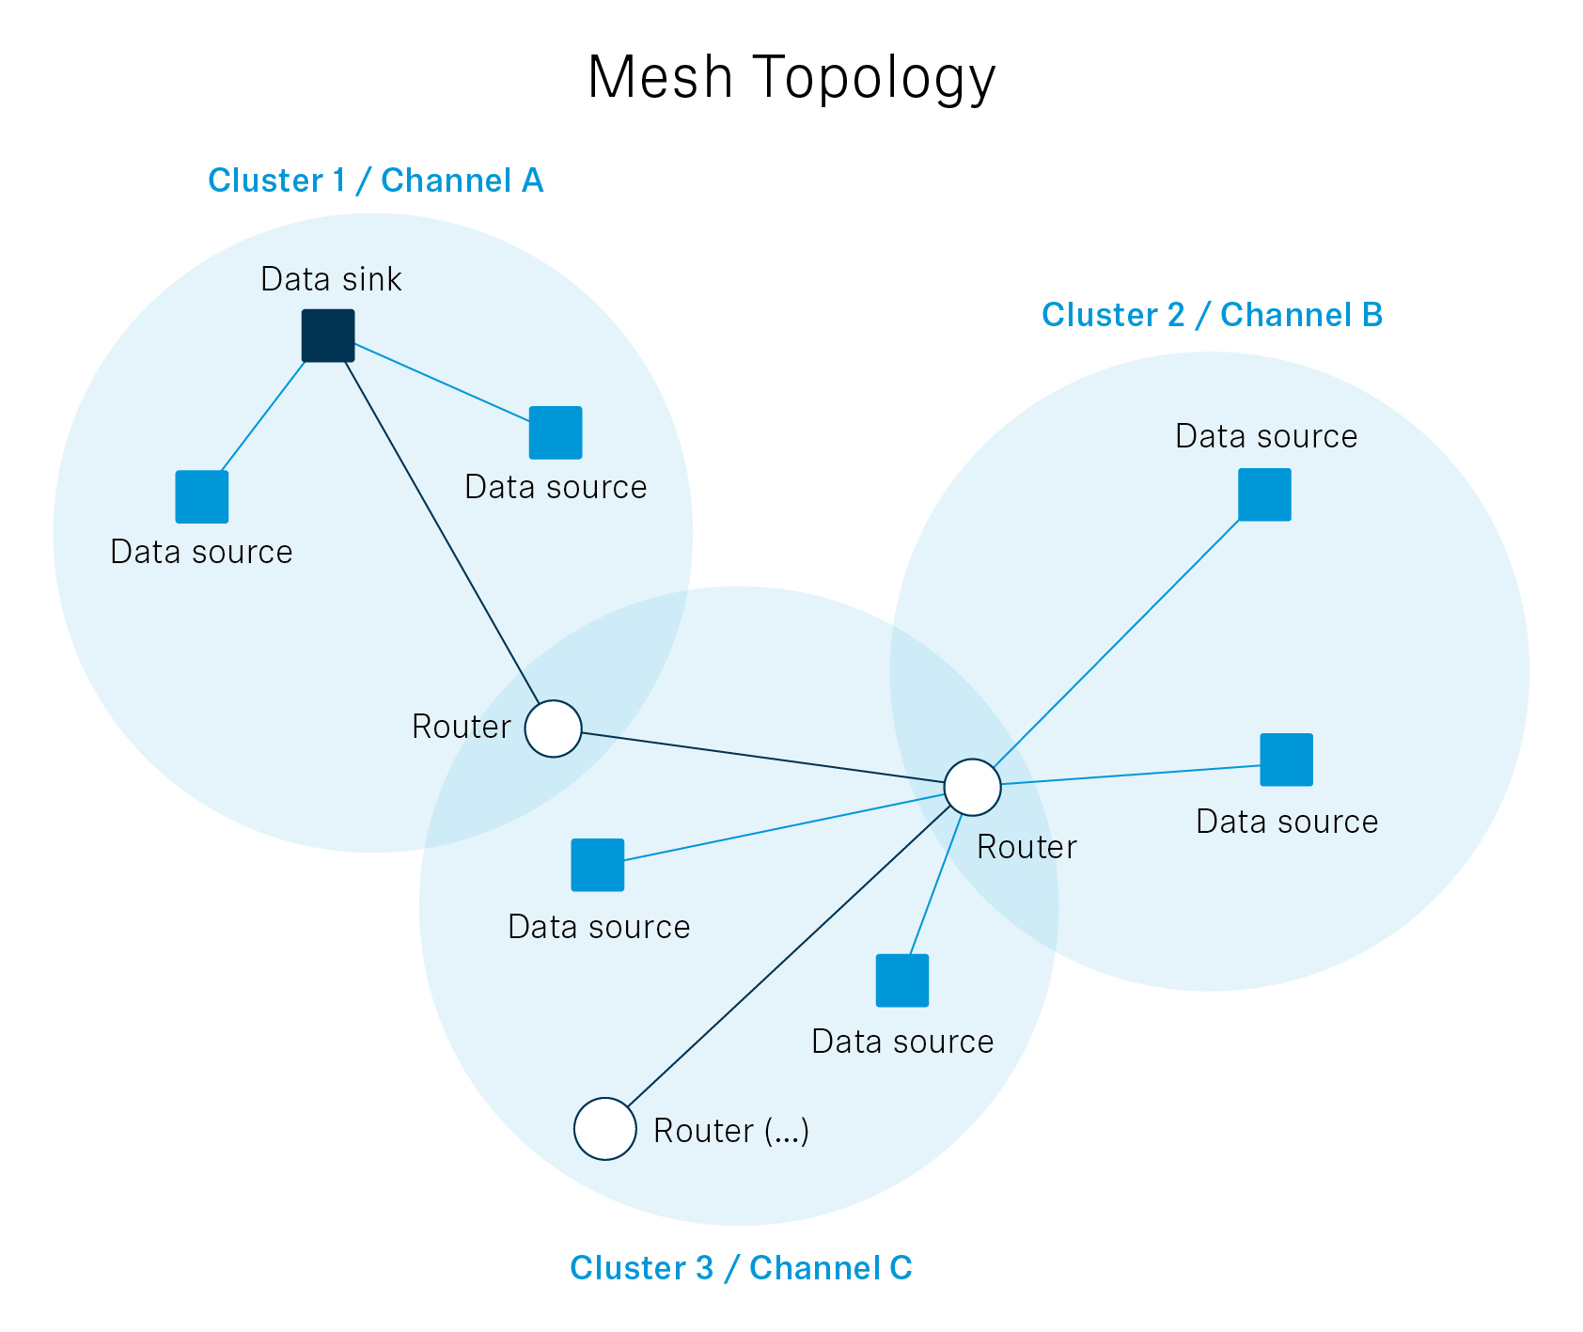 | A typical DECT NR+ mesh topology. The devices create their own network without requiring a base station to oversee them

Witting: When we look at the professional audio domain, NR+ promises higher device densities in venues and halls, an end-to-end latency of around a few milliseconds, improved robustness in challenging indoor RF due to the CP-OFDM technique it uses, and, via additional bands beyond 1.9 GHz, better global spectrum options than classic DECT. Classic DECT devices cannot be used in Mainland China, for example.

Zastrow: Overall, NR+ is designed for an “anywhere, by anyone, at any time” deployment: a licence-exempt, infrastructure-light standard that does not require agreements with network operators or heavy network planning to get started.

“NR+ is designed for an ‘anywhere, by anyone, at any time’ deployment: a licence-exempt, infrastructure-light standard that does not require agreements with network operators or heavy network planning to get started,” explains Zastrow. | 

Can you give us a rundown of the important players in DECT NR+, from research to industrial?
Wilzeck: Let’s begin with the Franco-German research project, MERCI, a 30-month research collaboration between the media & events sector, industry partners, and universities, which concluded at the end of July 2025. This was the first non-cellular 5G research project to involve professional audio and entertainment right from the start, and I had the absolute pleasure of being the consortium lead.

MERCI stands for Media and Event production via Resilient Communication on IoT Infrastructure. The initiative was jointly funded by the German Federal Ministry for Economic Affairs and Climate Action, the French Ministère de l’Economie et des Finances et de la Relance (MEFR) and bpi France. The public MERCI final workshop took place in 2025 and impressively mapped the state-of-the-art of DECT NR+ as well as the huge potential of this technology. For example, ATEME demoed an immersive audio solution using MPEG-H object audio, thereby implementing the world’s first object audio transmission via DECT NR+.

 | “While preserving the licence-exempt, plug-and-play nature that have made classic DECT so successful, DECT NR+ delivers lower latency, higher connection densities and flexible topologies,” notes Witting.

Zocher: Research collaboration and community networking are fostered through the DECT Forum’s Academia Industry Roundtable (AIR). AIR helps connect industry, universities and research institutions on the research and ecosystem side of DECT NR+ under a clear legal and funding framework. AIR plays an important role in aligning the pre-competitive innovation community around DECT NR+, and in linking academic research with industrial development.

Another important funding project besides MERCI is OpenDECT-X, a ten-month project which launched on 1 May 2026 and is funded by the German Federal Ministry of Research, Technology and Space. The project aims to close a major gap in the DECT NR+ ecosystem: Although the standard itself has been defined, there is currently no open-source reference implementation that is freely available, modifiable and well-documented. The existing protocol stacks are proprietary, which creates high barriers to market entry for small and medium-sized enterprises and limits academic research to a black-box approach. OpenDECT-X lays the foundation for a modular and interoperable open DECT NR+ protocol stack.

“The MERCI final public workshop in 2025 impressively mapped the state of the art of DECT NR+ and the huge potential of this technology,” states Wilzeck. | 

Witting: The Opener Initiative develops and maintains Opener, an open reference implementation of the DECT-2020 NR protocol stack covering the Media Access Control (MAC) and upper layers. The initiative brings together different existing stacks developed by its members and aims to consolidate them into a unified open-source solution that supports the full range of DECT NR+ use cases. Opener combines community-driven development with industrial usability, implementing the OpenDECT-X vision of an open ecosystem.

Why do government grants and programs like MERCI and OpenDECT-X play such a vital role? Is there not enough money with the companies that want to use DECT NR+ in products or in their own company-wide applications?
Zocher: Government grants and projects like MERCI fund high-risk, early work on DECT NR+ that individual companies cannot easily justify from product budgets, even if they are financially strong. They also create a safe legal environment for collaboration – with clear frameworks for funding, intellectual property and competition law. Companies and universities can work together on cross-industry research, multi-vendor demos and reference architectures that benefit the whole ecosystem but don’t immediately pay off for any single firm.

Public funding helps de-risk the development of technologies by validating standards and proving interoperability across industries. Grants like those for the MERCI project accelerate ecosystem maturity, broaden participation, especially as regards small and medium-sized enterprises, and ensure that open standards like DECT NR+ can reach a level of readiness where large-scale industrial deployment becomes economically viable.

 | “Government grants and projects like MERCI fund high-risk, early work on DECT NR+ that individual companies cannot easily justify from product budgets, even if they are financially strong,” says Zocher.

Professional audio applications have quite stringent requirements on latency, and demand consistently high transmission quality. How is DECT NR+ going to fulfil these needs?
Witting: DECT NR+ targets IMT-2020 URLLC-class performance, URLLC stands for ultra-reliable, low latency communication, with end-to-end latencies of a few milliseconds and extremely high reliability thanks to CP-OFDM, advanced coding and HARQ. Older DECT standards were optimised for telephony and low-rate data; they lack the spectral efficiency, flexible scheduling and Quality of Service required for dense, phase-coherent, low-latency audio, which NR+ now addresses.

(Ends)

This interview is an abridged and slightly edited version of this full interview. The interview images can be downloaded as web-resolution jpgs and as high-resolution jpgs.

Useful links:
ETSI Technical Standard
https://franco-german-5g-ecosystem.eu/merci/
https://newsroom.sennheiser.com/merci-project-takes-dect-nr-from-vision-to-reality.
http://opener-initiative.org
DECT NR+ interoperability

About the Sennheiser brand
We live and breathe audio. We are driven by the passion to create audio solutions that make a difference. Building the future of audio and bringing remarkable sound experiences to our customers – this is what the Sennheiser brand has represented for more than 80 years. While professional audio solutions such as microphones, meeting solutions, streaming technologies and monitoring systems are part of the business of Sennheiser electronic SE & Co. KG, the business with consumer devices such as headphones, soundbars and speech-enhanced hearables is operated by Sonova Holding AG under the license of Sennheiser.
www.sennheiser.com
www.sennheiser-hearing.com

Pro Audio Press Contact
Stephanie Schmidt
stephanie.schmidt@sennheiser.com
+49 5130 600-1275

